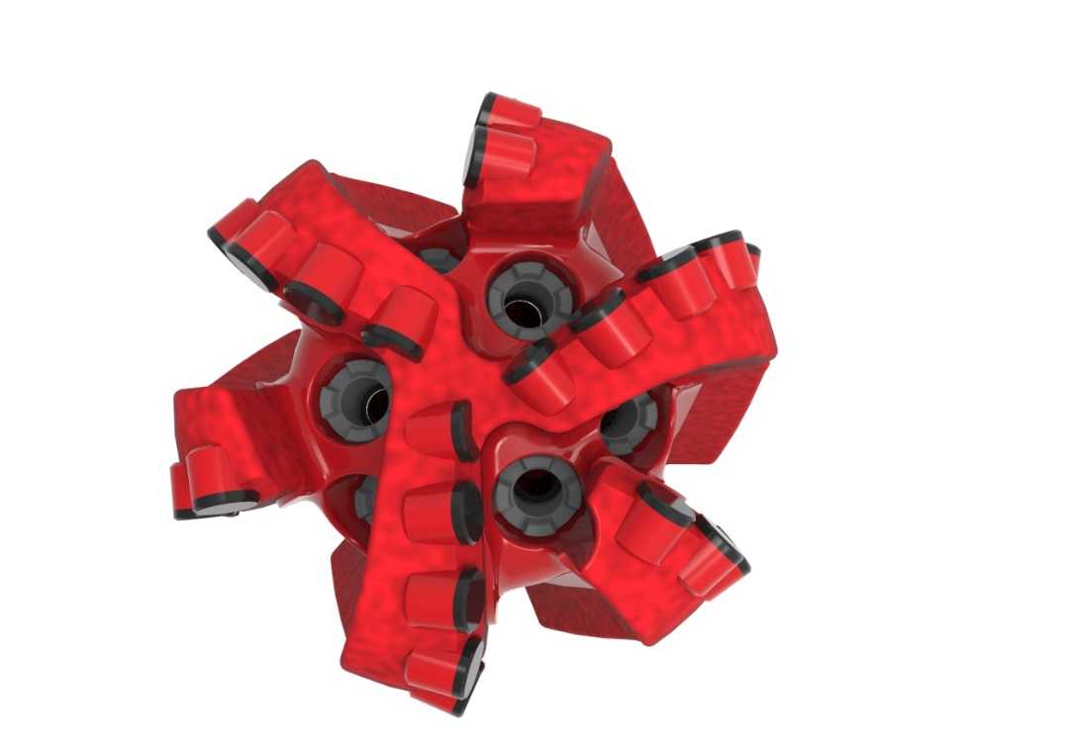
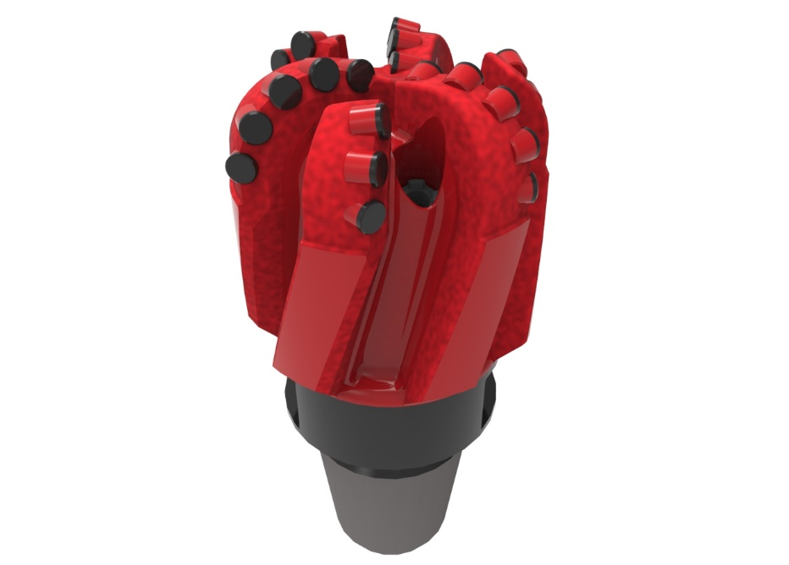

Drill Bit Specifications:
Cutter Size (Primary, Sec) | 3/64”
Cutter Count (Total, Gage) | 26,6
Blade Count | 6
Gage Length (Inches) | 2.50
Nozzle Count (Primary, Sec.) | 6
Nozzle Series (Primary, Sec.) | 35
JSA (Sq. Inches) | 4.924
Max. TFA (Sq. Inches) | 0.66
Operating Parameters:
Max. Weight on Bit (1,000 Lbs.) | 15
Make-up Torque (ft/lbs) | 4,613
Nominal Dimensions:
Overall Length (Inches) | 9.69
Make Up Length (Inches) | 6.31
Bit Breaker | SKB-21013
Connection | Ø2-7/8" API Reg.
Approx. Weight (Lbs.) | *20

*Long tool joint available upon request (adds 6” to fishing neck, makeup and overall length, and 64 lbs. to approximate weight).
*Long tool joint available upon request (adds 6” to fishing neck, makeup and overall length, and 64 lbs. to approximate weight).

Standard Features:

- Large open face volume assists cuttings removal
- Six nozzles optimize blade cleaning and cuttings removal
- Premium grade cutters maximize ROP and Life

611-SR Nomenclature Explained:

• | 6 | = | Number of blades
• | 11 | = | Primary Cutter Size (11mm)
• | SR | = | Single Row of Cutters
• | 6 | = | Number of Nozzles
*Long tool joint available upon request (adds 6” to fishing neck, makeup and overall length, and 64 lbs. to approximate weight).

